SIMPLE COURSE REVISION & QUESTION BANK PLANNER
@CREATIVITY THINK (9483175986/7019689991)

ABSTRACT:
Simple Course Revision & Question Bank Planner is a web-based platform designed to help students and coaching centers plan, track, and optimize their study schedules. The system enables users to create subject-wise topic lists, set revision timelines, add personalized question banks or flashcards, and monitor progress through a dashboard. Administrators or teachers can provide base syllabus templates, moderate shared question banks, identify challenging topics using statistics, and generate reports on topic completion. Built with Django and Django REST Framework for backend operations, and React with Redux and axios for frontend interactivity, the platform enhances learning efficiency, structured study planning, and performance tracking..

INTRODUCTION OF THE PROJECT:
Students and self-study groups often face challenges in organizing study topics, planning revision schedules, and tracking their progress efficiently. Without a structured system, it is difficult to identify knowledge gaps or monitor improvements. The Simple Course Revision & Question Bank Planner addresses these issues by providing a centralized, digital solution for managing course content, creating question banks, and monitoring study progress. The platform allows both students and instructors to interact effectively, ensuring structured learning and timely feedback..

PROJECT OBJECTIVES:

• Enable students to create subject-wise topic lists and set target dates
• Provide tools to add personalized Q&A or flashcards
• Track completed topics and revision schedules
• Offer a progress dashboard with visual insights on study performance
• Allow administrators/teachers to provide base syllabus templates
• Moderate and manage shared question banks
• Identify difficult topics using statistical analysis
• Generate dashboard analytics per subject or class
• Export topic completion and progress reports

PROBLEM OF THE STATEMENT:
Traditional study planning relies on static notes, paper schedules, and ad-hoc revision, making it difficult to track progress or identify weak areas. Students may struggle to manage time effectively, while instructors lack visibility into learners’ progress. This project solves these problems by offering a digital platform for structured course planning, question bank management, progress tracking, and data-driven analytics, improving learning efficiency and accountability..

MOTIVATION OF THE PROJECT:
• To support structured course revision and study planning
• To facilitate creation and organization of personal question banks
• To track progress and completion status of topics
• To assist students in achieving learning goals efficiently
• To provide instructors with analytics for better guidance
• To highlight difficult topics for targeted intervention
• To improve accountability and motivation among learners
• To streamline reporting and assessment of learning outcomes

BLOCK DAIGRAM OF PROJECT:

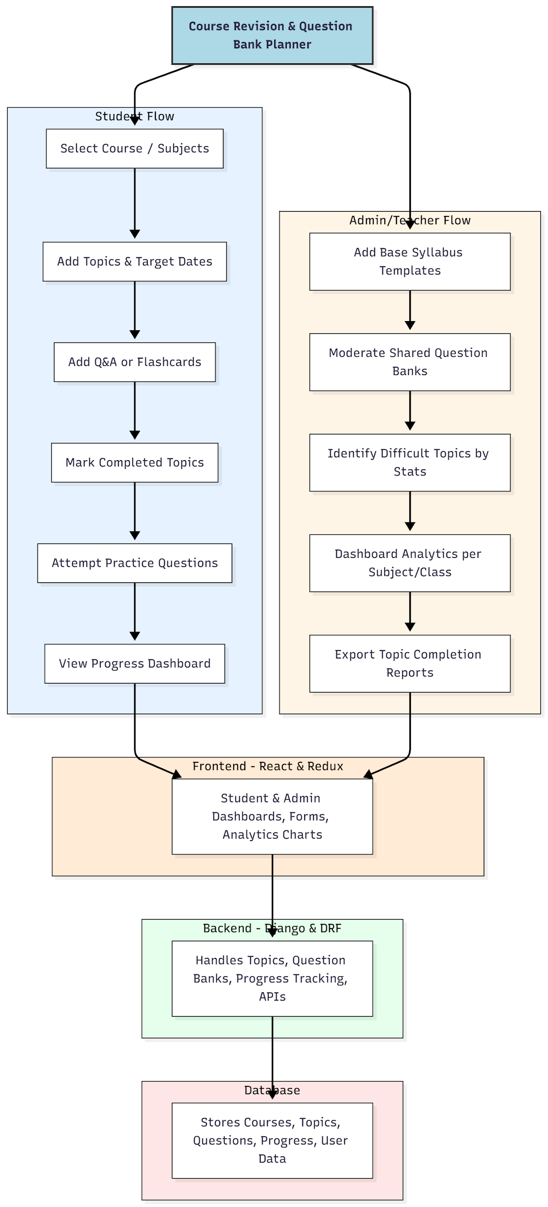

WORKING OF THE PROJECT:
Students begin by selecting courses and subjects, then add topics with target dates and input personal question banks or flashcards. Completed topics are marked, and practice questions are attempted periodically. The dashboard displays progress metrics, helping learners track their study efficiency. Administrators or teachers add base syllabus templates, moderate shared question banks, identify challenging topics, and monitor overall performance using analytics dashboards. Reports on topic completion and student progress can be exported for further review. The backend manages all data storage, APIs, and analytics, while the frontend provides an interactive, real-time dashboard..

SOFTWARE REQUIREMENT:
- Backend:
  - Python 3.x
  - Django
  - Django REST Framework
  - SQLite/PostgreSQL
- Frontend:
  - Node.js and npm
  - React.js
  - Axios
- Development Tools:
  - Visual Studio Code
  - Postman (for testing APIs)
  - Git/GitHub (for version control)
- Server/Deployment (Optional):
  - Gunicorn, Nginx, or Heroku/AWS for hosting

ADVANTAGES OF THE PROJECT:

• Structured course revision planning
• Personalized question bank creation
• Progress tracking with dashboards and charts
• Statistical analysis of difficult topics
• Exportable reports for students and instructors
• Improves learning efficiency and accountability
• Enhances interaction between students and teachers
• Supports coaching centers, self-study groups, and individual learners

APPLICATIONS OF THE PROJECT:
• Students managing personal or coaching center study plans
• Coaching and tuition centers for structured learning
• Self-study groups for organized revision
• Schools and colleges with course tracking requirements
• Examination preparation and progress monitoring

REFERENCES:

- Django REST Framework Documentation — Django Software Foundation. Django Documentation. Available: https://docs.djangoproject.com/
- Django REST Framework. DRF Documentation. Available: https://www.django-rest-framework.org/
- React. React Official Documentation. Available: https://reactjs.org/docs/getting-started.html
- Redux. Redux Documentation. Available: https://redux.js.org/introduction/getting-started
- PostgreSQL Global Development Group. PostgreSQL Documentation. Available: https://www.postgresql.org/docs/
- MySQL. MySQL Reference Manual. Available: https://dev.mysql.com/doc/
- Git. Git Documentation. Available: https://git-scm.com/doc
- Node.js. Node.js Documentation. Available: https://nodejs.org/en/docs/
- Axios. Axios Documentation. Available: https://axios-http.com/docs/intro
- Socket.io Documentation – https://socket.io/docs/

